**Compiler Design Lab Report**

**19CSE401**

**Name: Nagireddy Kavyasree**

**Roll No: CH.EN.U4CSE22140**

|  |  |  |
| --- | --- | --- |
| **Experiment No** | **Topic Name** | **Date** |
| 1 | Basic Programs | 20-Jul-2025 to 9-Jul-2025 |
| 2 | Implementation of Lexical Analyzer Using Lex Tool | 14-Aug-2025 |
| 3 | Program to eliminate left recursion and factoring from the given grammar | 19-Aug-2025 |
| 4 | Implementation of LL(1) parsing | 24-Aug-2025 |
| 5 | Parser Generation using YACC | 29-Aug-2025 |
| 6 | Implementation of Symbol Table | 03-Sep-2025 |
| 7 | Implementation of Intermediate Code Generation | 08-Sep-2025 |
| 8 | Implementation of Code Optimization Techniques | 13-Sep-2025 |
| 9 | Implementation of Target code generation | 18-Sep-2025 |

**Name:** Nagireddy Kavyasree

**Roll no:** CH.EN.U4CSE22140

**Basic Programs**

1. **Aim:** Program to Identify Vowels and Consonants

**Algorithm:**

* Open the gedit text editor from Accessories under Applications menu.
* Specify the header file <stdio.h> between %{ and %}.
* Define the character patterns for vowels [aAeEiIoOuU], alphabets [a-zA-Z], whitespaces [ \t\n], and other characters ..
* Use translation rules to print whether the character is a vowel, consonant, or not an alphabet character.
* Call yylex() inside the main() function to begin lexical analysis.
* Save the program as vowelconsonant.l using the LEX language.
* Run the program using the LEX compiler to generate lex.yy.c.
* The generated lex.yy.c contains tables and routines to match input characters.
* Compile lex.yy.c using a C compiler to create an executable file.
* Run the executable to check each character in the input and classify it.

**Code:**

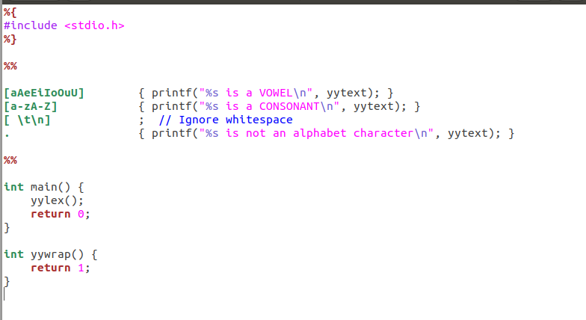

**Output: Name:** Nagireddy Kavyasree

**Roll no:** CH.EN.U4CSE22140

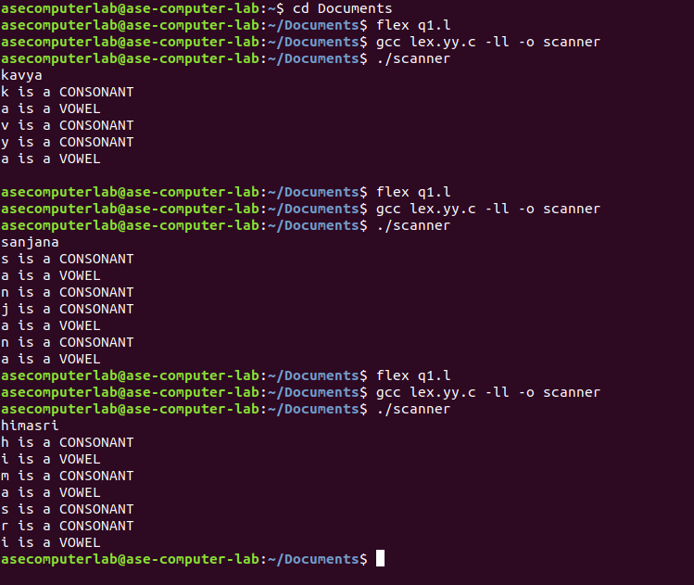

2. **Aim:** Program to Count Lines, Words, and Characters  
 **Algorithm:**

* Open the gedit text editor from Accessories under Applications menu.
* Include the header file <stdio.h> between %{ and %}.
* Declare and initialize line, word, and character counters.
* Define regular expressions for newline, whitespace, and words.
* Use translation rules to update the respective counters.
* Call yylex() inside the main() function.
* Print the final count of lines, words, and characters.
* Save the program as counter.l.
* Run the program using the LEX compiler to generate lex.yy.c.
* Compile lex.yy.c using a C compiler to produce the executable.
* Run the executable to perform the counting operation on input.

**Code: Name:** Nagireddy Kavyasree

**Roll no:** CH.EN.U4CSE22140

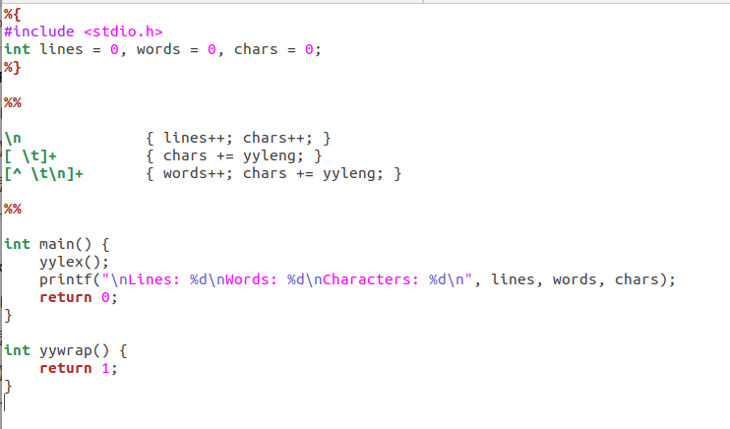

**Output:** 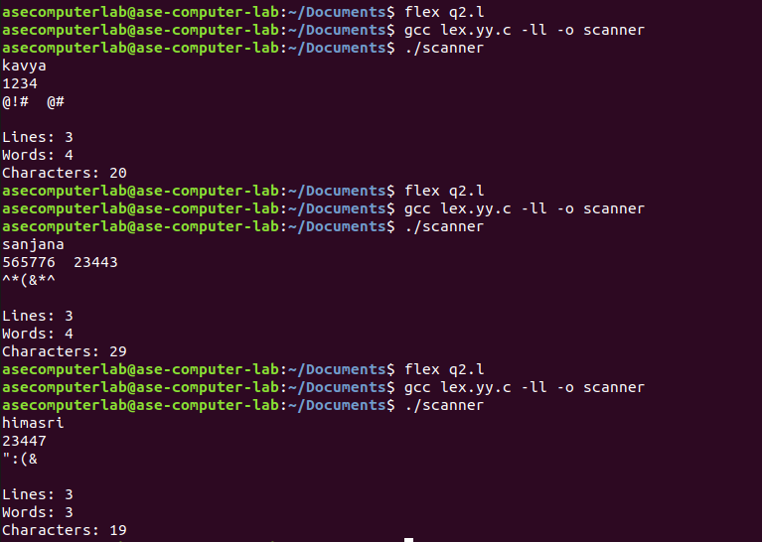

3. **Aim:** Program to Recognize Integers and Floating-Point Numbers  
  **Algorithm:**

* Open the gedit text editor from Accessories under Applications menu.
* Include the header file <stdio.h> between %{ and %}.
* Define patterns for floating point numbers, integers, whitespaces, and other characters.
* Use translation rules to identify and print whether input is float, integer, or not a number.
* Ignore whitespaces like tab, space, and newline.
* Call yylex() inside the main() function to start lexical analysis.
* Save the program as numcheck.l.
* Run the program using the LEX compiler to generate lex.yy.c.
* Compile lex.yy.c using a C compiler to get the executable.
* Run the executable to test inputs and identify the type of number.

**Name:** Nagireddy Kavyasree

**Roll no:** CH.EN.U4CSE22140

**Code:**

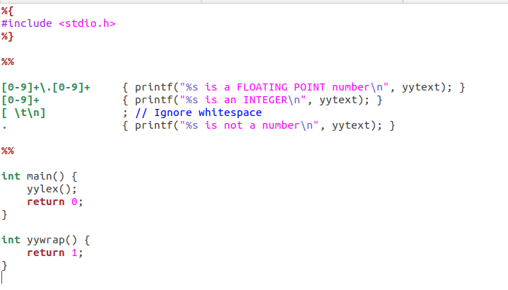

**Output:** 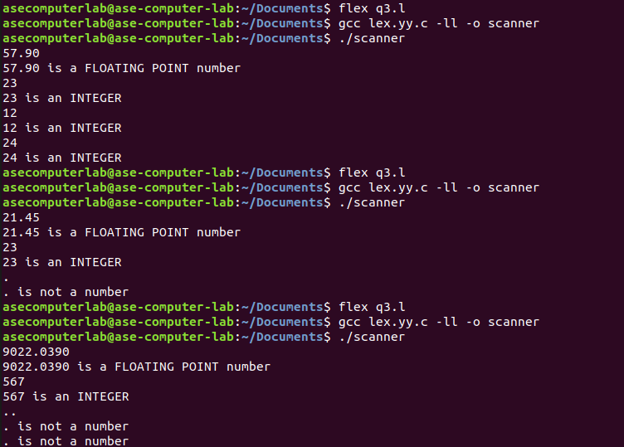

4. **Aim:** Program to Recognize C Keywords  
 **Algorithm:**

* Open the gedit text editor from Accessories under Applications menu.
* Include the header file <stdio.h> between %{ and %}.
* Define regular expressions for C keywords, identifiers, whitespaces, and other characters.
* Use translation rules to print whether input is a C keyword, identifier, or something else.
* Ignore spaces, tabs, and newline characters.
* Call yylex() in the main() function to begin lexical analysis.
* Save the program as keywordid.l.
* Run the program through the LEX compiler to generate lex.yy.c.
* Compile lex.yy.c using a C compiler to get the final executable.
* Run the executable to classify each token as keyword, identifier, or other.

**Code:**

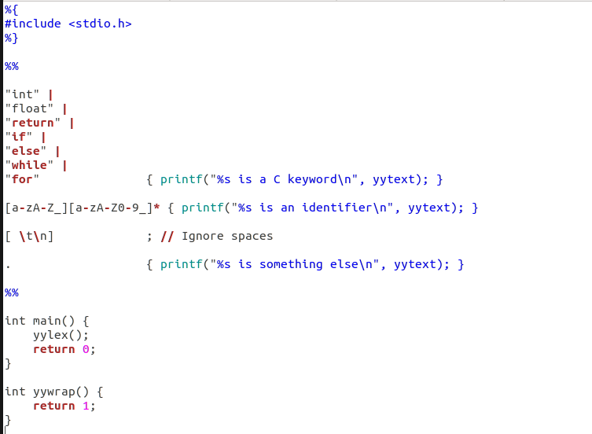

**Output:**

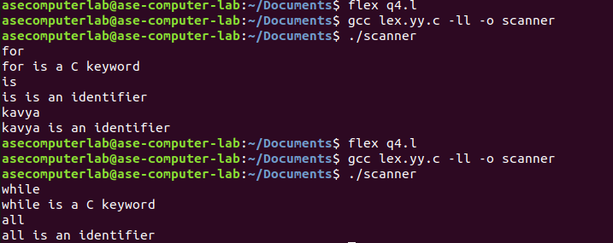

5. **Aim:** Program to Recognize Operators  
  **Algorithm:**

* Open the gedit text editor from Accessories under Applications menu.
* Include the header file <stdio.h> between %{ and %}.
* Define regular expressions for relational operators, arithmetic/assignment operators, whitespaces, and other characters.
* Use translation rules to check and print whether input is a relational operator, arithmetic/assignment operator, or not an operator.
* Ignore whitespaces like tab and newline characters.
* Call yylex() inside the main() function to begin lexical analysis.
* Save the program as operatorcheck.l.
* Run the program through the LEX compiler to generate lex.yy.c.
* Compile lex.yy.c using a C compiler to get the executable.
* Run the executable to test and classify the input operators.

**Code:**

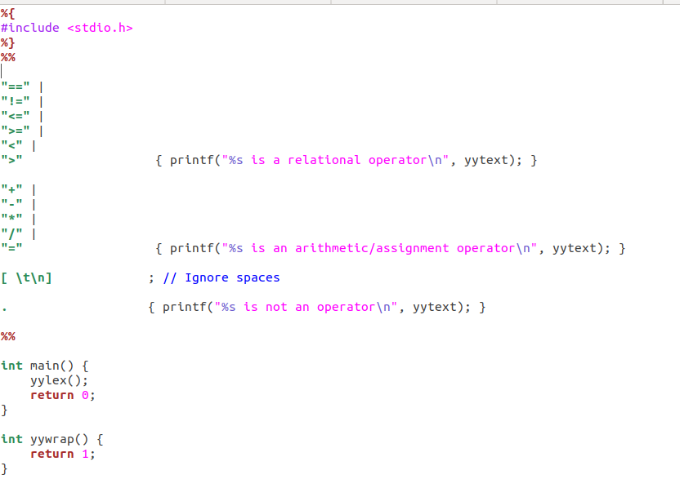

**Output:**

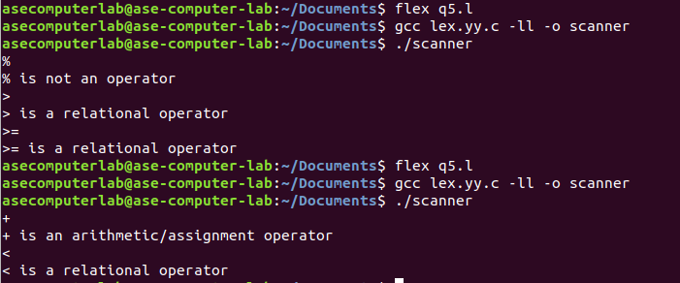

**Name:** Nagireddy Kavyasree

**Roll no:** CH.EN.U4CSE22140

**EXPERIMENT NO – 1**

**Aim:** To implement Lexical Analyzer Using Lex Tool

**Algorithm:**

* Open gedit text editor from Accessories in Applications.
* Specify the header files to be included inside the declaration part (i.e. between %{ and %}).
* Define the digits 0-9 and identifiers a-z and A-Z.
* Using translation rules, define the regular expressions for digit, keywords, identifiers, operators, header files etc. If matched with the input, store and display using yytext.
* Inside procedure main (), use yyin() to point to the current file being passed by the lexer.
* The specification of the lexical analyzer is prepared by creating a program lab1.l in the LEX language.
* The lab1.l program is run through the LEX compiler to produce equivalent C code named lex.yy.c.
* The program lex.yy.c consists of a table constructed from the regular expressions of lab1.l, along with standard routines that use the table to recognize lexemes.
* Finally, the lex.yy.c program is run through a C compiler to produce an object program a.out, which is the lexical analyzer that transforms an input stream into a sequence of tokens.

**Code:**

**Lab1.l:**

**Name:** Nagireddy Kavyasree

**Roll no:** CH.EN.U4CSE22140

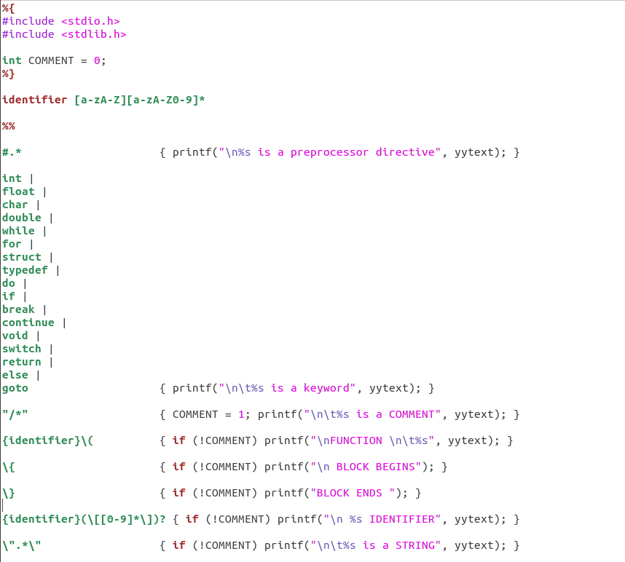

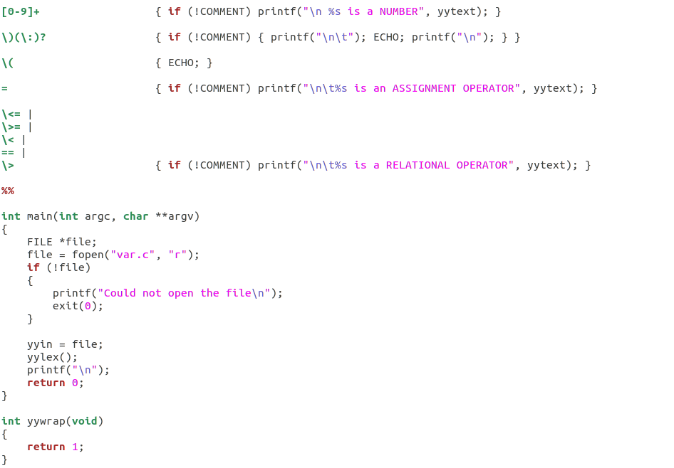

**Name:** Nagireddy Kavyasree

**Roll no:** CH.EN.U4CSE22140

**Var.c:**

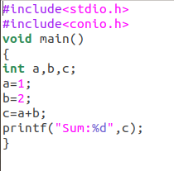

**Output:**

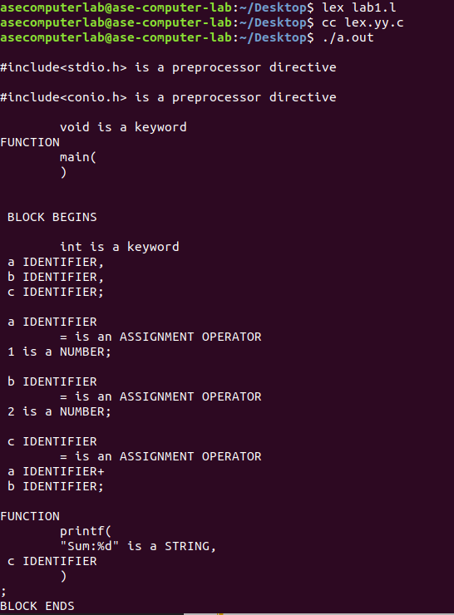

**Name:** Nagireddy Kavyasree

**Roll no:** CH.EN.U4CSE22140

**EXPERIMENT NO – 2**

**Aim:** Program to eliminate left recursion and factoring from the given grammar

**Algorithm:**

* Open any text editor and start writing a C program.
* Include the necessary header files: stdio.h and string.h.
* Declare required character arrays for grammar parts and variables for loop counters and positions.
* Prompt the user to enter a production in the form A->alpha|beta.
* Use fgets() to read the entire input line, removing the trailing newline.
* Extract the portion before the | into part1 and the portion after into part2.
* Find the longest common prefix between part1 and part2 and store it in modifiedGram.
* After the common part, append 'X' to modifiedGram to denote the new non-terminal.
* Create newGram to store the restructured productions from the remaining suffixes of part1 and part2.
* Display the final left-factored productions using printf().

**Code:**

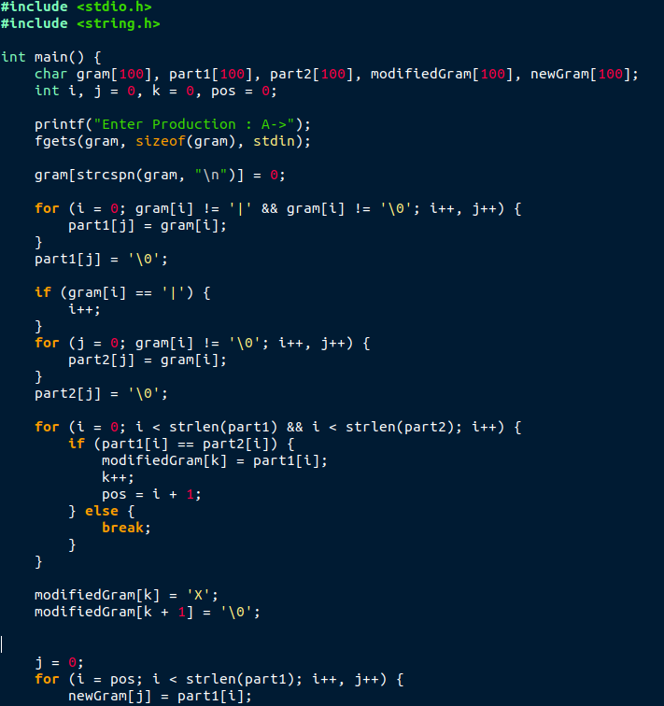

**Name:** Nagireddy Kavyasree

**Roll no:** CH.EN.U4CSE22140

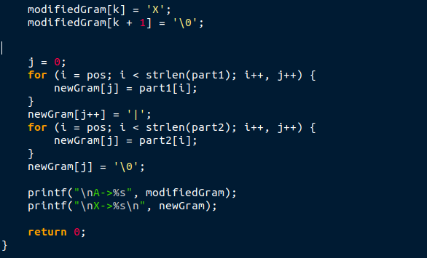

**Output:**

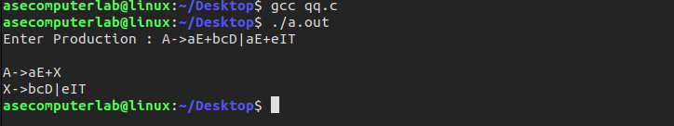

**Name:** Nagireddy Kavyasree

**Roll no:** CH.EN.U4CSE22140

**EXPERIMENT NO – 3**

**Aim:** To implement LL(1) parsing using C program.

**Algorithm:**

* Initialize parsing table m[][][] and size table size[][].
* Read input string from user and append '$' at the end.
* Initialize stack with '$' at the bottom and push start symbol 'e'.
* Print header for stack and input.
* Repeat until both stack top and input symbol are not '$':
* If stack top equals input symbol, pop the stack and advance input.
* Otherwise, determine row index from stack top.
* Determine column index from current input symbol.
* If no production rule exists in table, print error and exit.
* If rule is epsilon (n), pop the stack.
* If rule is a terminal like i, replace stack top with that terminal.
* Otherwise, push the right-hand side of the production rule (in reverse order) onto the stack.
* Print current contents of stack and input string.
* Continue until parsing ends.
* If successful, print “SUCCESS”.

**Code:**

**Name:** Nagireddy Kavyasree

**Roll no:** CH.EN.U4CSE22140

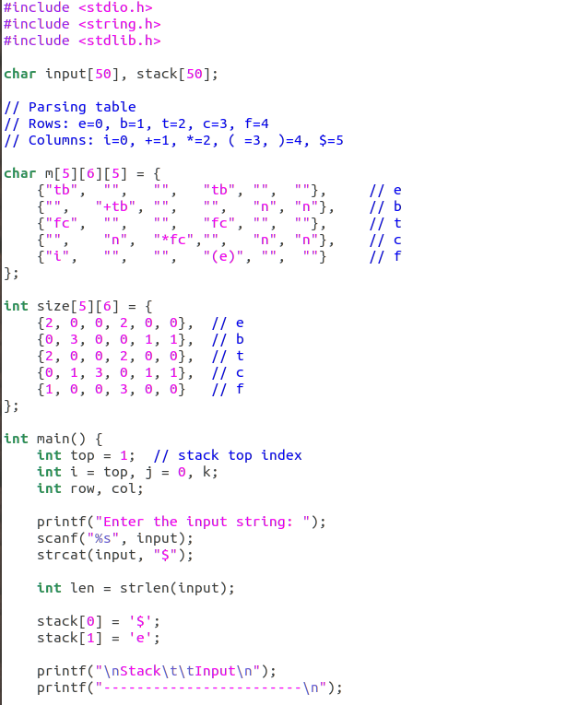

**Name:** Nagireddy Kavyasree

**Roll no:** CH.EN.U4CSE22140

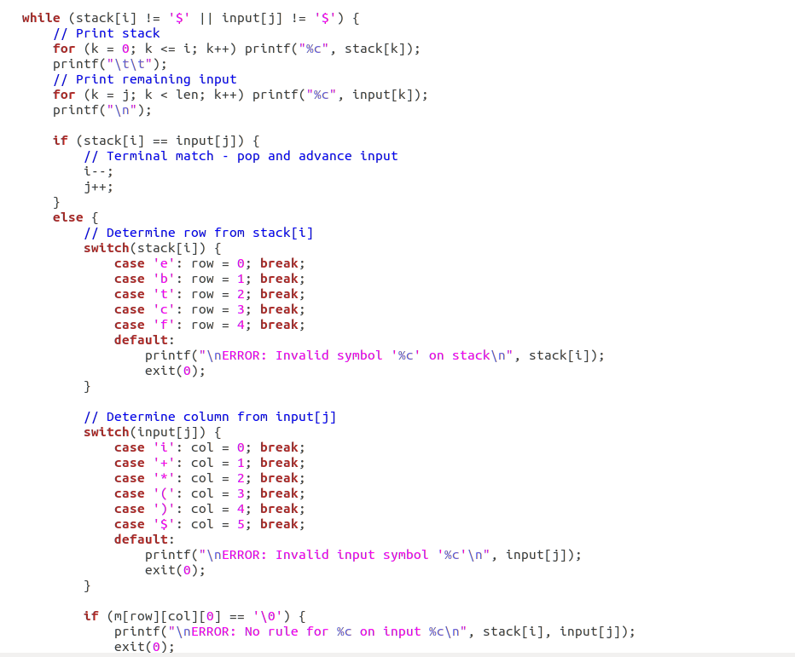

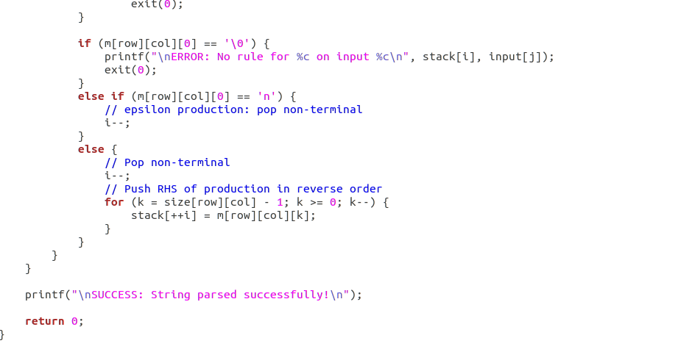

**Name:** Nagireddy Kavyasree

**Roll no:** CH.EN.U4CSE22140

**Output:**

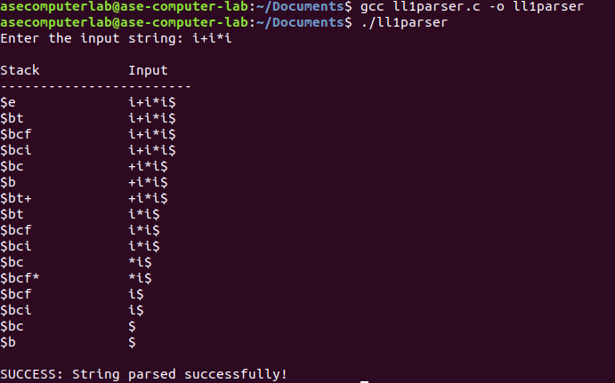

**Name:** Nagireddy Kavyasree

**Roll no:** CH.EN.U4CSE22140

**EXPERIMENT NO – 4**

**Aim:** To write a program in YACC for parser generation.

**Algorithm:**

* Start program and define grammar tokens (NUMBER, operators, parentheses) and their precedence.
* Accept input lines containing arithmetic expressions.
* Parse the expression according to grammar rules (+, -, *, /, parentheses, unary minus, numbers).
* Perform arithmetic operations as semantic actions during parsing.
* Use yylex() to read input, skip spaces, and return tokens (numbers or operators).
* When a number is found, read it fully and assign to yylval.
* Continue parsing until the entire expression is reduced.
* Print the evaluated result of the expression and repeat for next input.

**Code:**

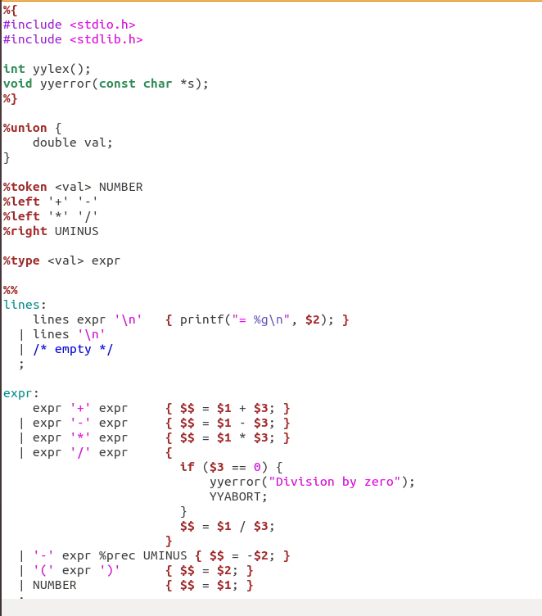

**Name:** Nagireddy Kavyasree

**Roll no:** CH.EN.U4CSE22140

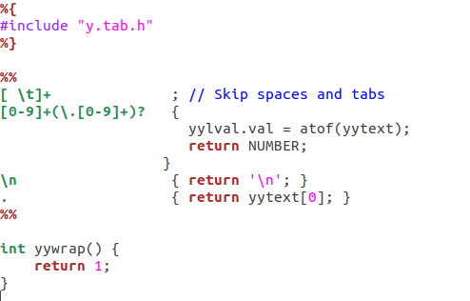

**Output:**

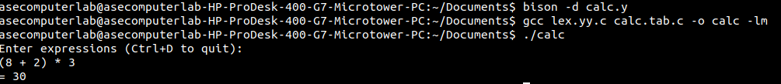

**Name:** Nagireddy Kavyasree

**Roll no:** CH.EN.U4CSE22140

**EXPERIMENT NO – 5**

**Aim:** To implement Symbol Table.

**Algorithm:**

* Start the program and read an expression ending with $.
* Store the input characters into an array.
* Display the given expression.
* Traverse each character of the expression.
* If the character is an alphabet, classify it as an identifier and store with its address.
* If the character is an operator (+, -, *, =), classify it as an operator and store with its address.
* Display the complete symbol table and end the program.

**Code:**

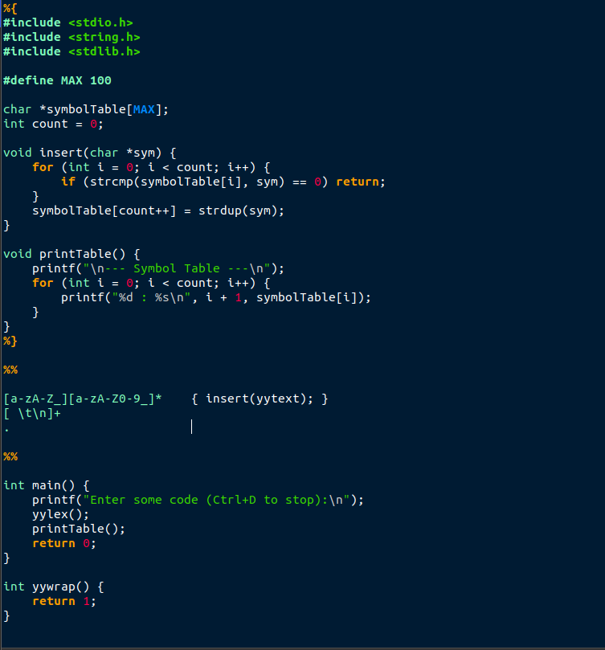

**Name:** Nagireddy Kavyasree

**Roll no:** CH.EN.U4CSE22140

**Output:**

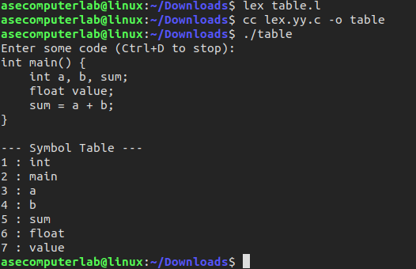

**Name:** Nagireddy Kavyasree

**Roll no:** CH.EN.U4CSE22140

**EXPERIMENT NO – 6**

**Aim:** To implement intermediate code generation.

**Algorithm:**

* Start the program and read an arithmetic expression as input.
* Scan the expression and record the positions of operators (:, /, *, +, -).
* For each operator, find its left operand and right operand.
* Generate a temporary variable for the result and replace the operator with it.
* Print the intermediate code in the form of three-address statements (T := operand1 op operand2).
* Repeat the process until the full expression is reduced.
* Print the final assignment statement and end the program.

**Code:**

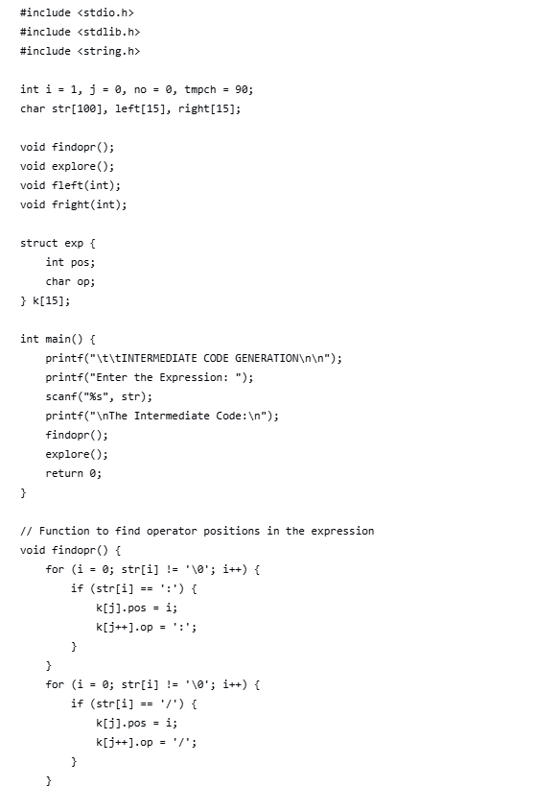

**Name:** Nagireddy Kavyasree

**Roll no:** CH.EN.U4CSE22140

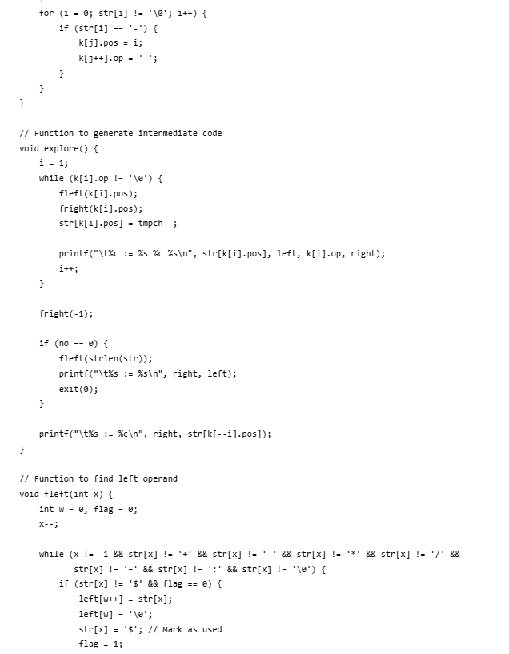

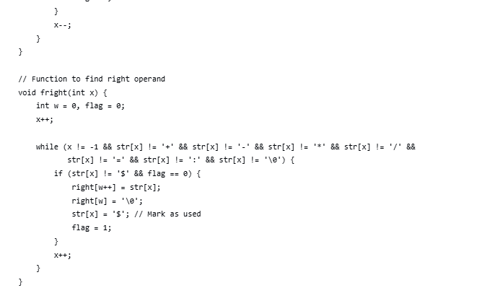

**Name:** Nagireddy Kavyasree

**Roll no:** CH.EN.U4CSE22140

**Output:**

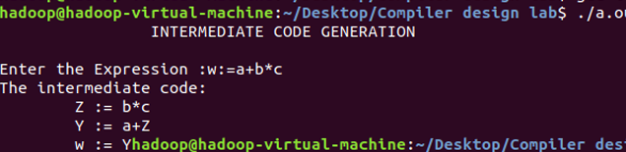

**EXPERIMENT NO – 7**

**Aim:** To implementation of Code Optimization Techniques

**Algorithm:**

* Start the program and read the number of expressions (n).
* For each expression, input the left-hand side variable and the right-hand side expression.
* Display the original intermediate code.
* Perform dead code elimination by keeping only those statements whose results are used later.
* Perform common subexpression elimination by checking if two expressions compute the same value and replacing duplicates.
* Update references so that redundant variables are replaced with the optimized variable.
* Print the final optimized code and end the program.

**Code:**

**Name:** Nagireddy Kavyasree

**Roll no:** CH.EN.U4CSE22140

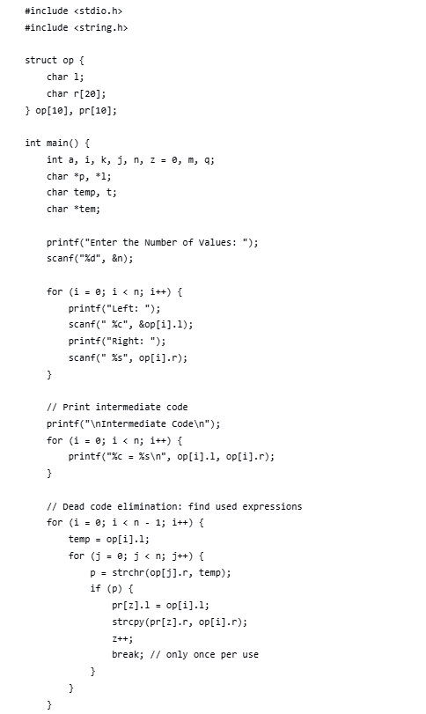

**Name:** Nagireddy Kavyasree

**Roll no:** CH.EN.U4CSE22140

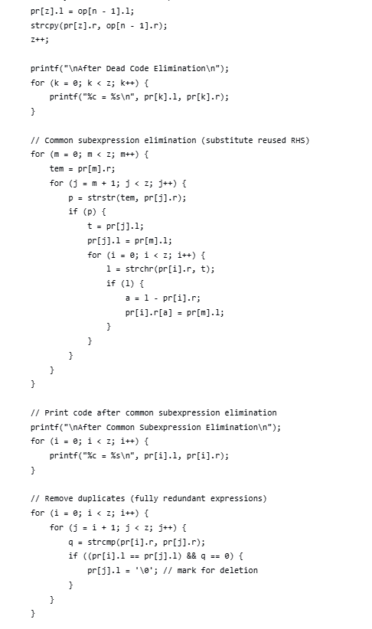

**Name:** Nagireddy Kavyasree

**Roll no:** CH.EN.U4CSE22140

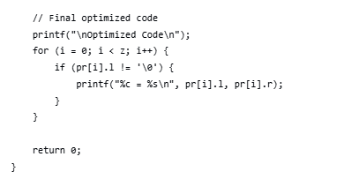

**Output:**

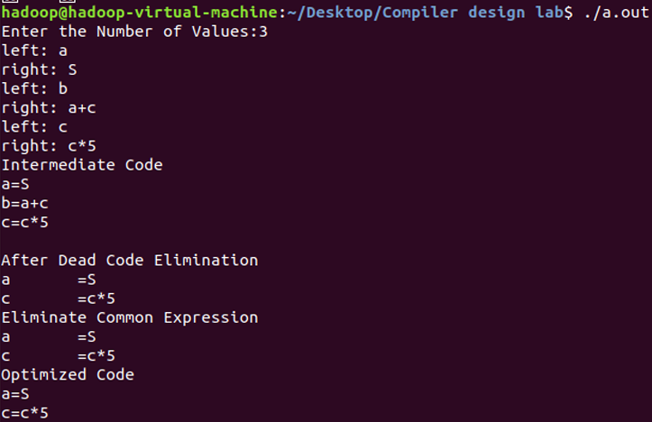

**Name:** Nagireddy Kavyasree

**Roll no:** CH.EN.U4CSE22140

**EXPERIMENT NO – 8**

**Aim:** To write a program that implements the target code generation

**Algorithm:**

* Read the input string from the user.
* Process each input string and use a switch–case structure to identify the operator.
* Load the input variables into temporary variables (operands) and display them using the instruction LOAD.
* Based on the arithmetic operator, display the corresponding operation (ADD, SUB, MUL, DIV) using switch–case.
* Generate the three-address code representation for each operation.
* If the operator is an assignment (=), store the result in the target variable and display it using STORE.
* Repeat this process for each line of the input string.
* Display the final output, which is the transformed assembly-like machine code.

**Code:**

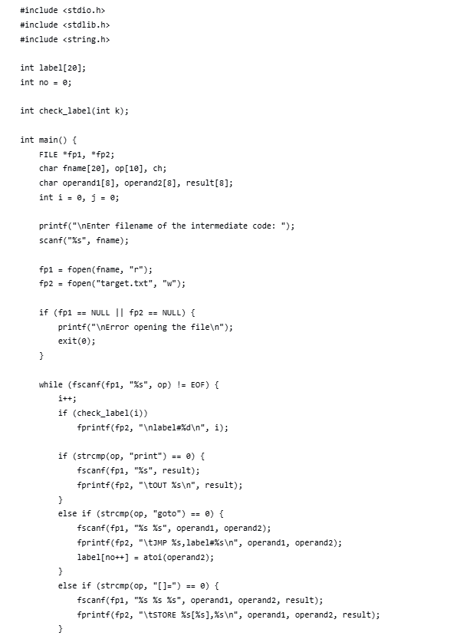

**Name:** Nagireddy Kavyasree

**Roll no:** CH.EN.U4CSE22140

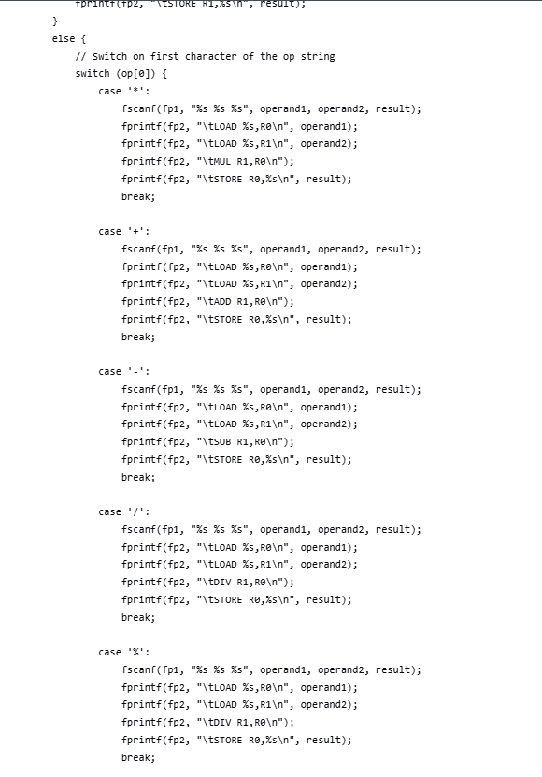

**Name:** Nagireddy Kavyasree

**Roll no:** CH.EN.U4CSE22140

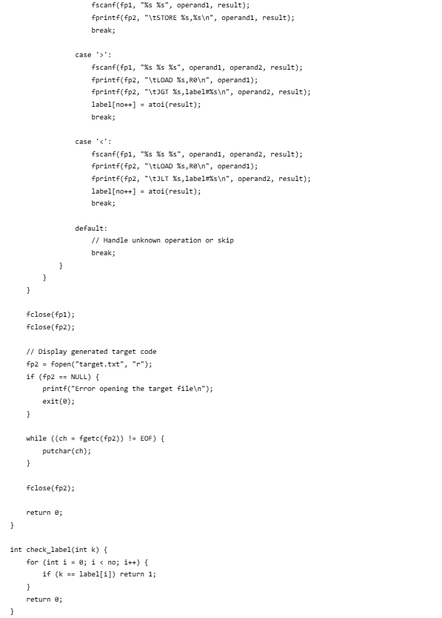

**Output:**

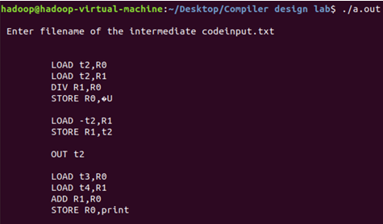

**Name:** Nagireddy Kavyasree

**Roll no:** CH.EN.U4CSE22140